**Lab#7 Using PHP CURL,**

**Implementing Web Scrapping using CURL to fetch the relevant data from IMDB Movie Website.**

**Final Outcome:**

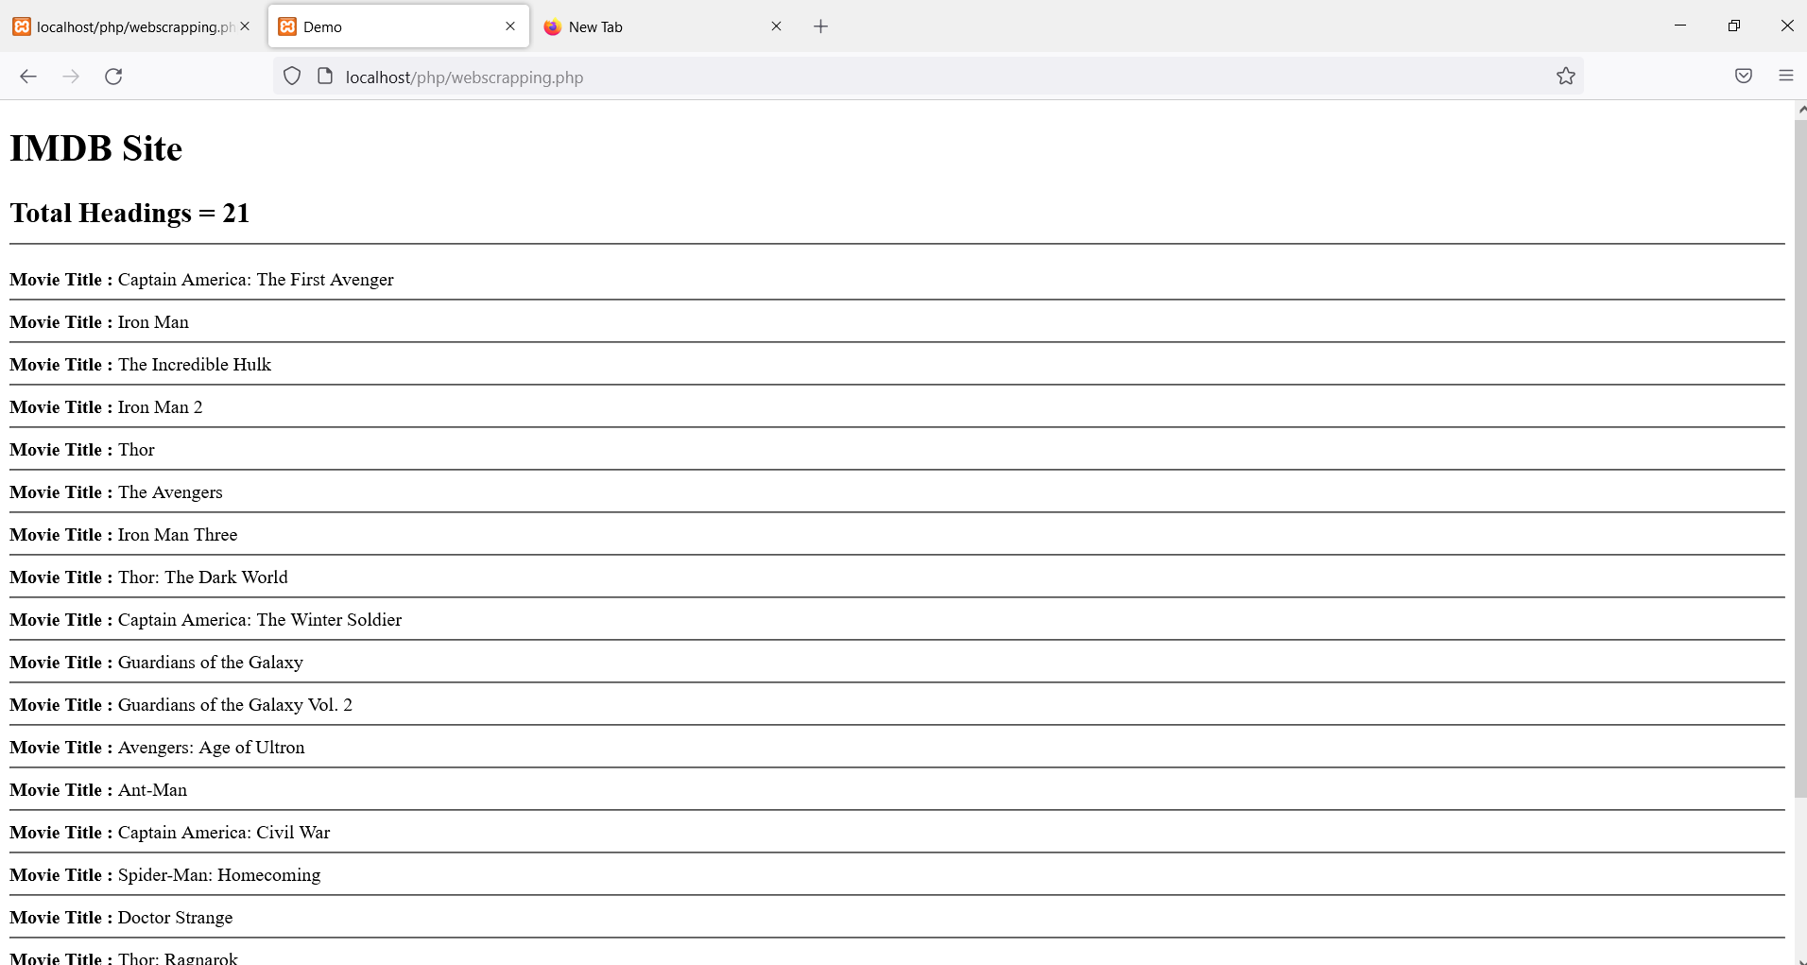

**Code Snippet:**

<!DOCTYPE html>

<html>

<head>

<title>Demo</title>

<head>

<body>

<h1>IMDB Site</h1>

<?php

$curl=curl_init();

if(!$curl){

die("Cannot init curl.");

}

curl_setopt($curl,CURLOPT_URL,"https://www.imdb.com/list/ls020525837/");

curl_setopt($curl,CURLOPT_RETURNTRANSFER,true);

curl_setopt($curl,CURLOPT_SSL_VERIFYHOST,false);

curl_setopt($curl,CURLOPT_SSL_VERIFYPEER,false);

$result = curl_exec($curl);

if(curl_errno($curl)){

echo "Error: ".curl_error($curl);

} else {

$regex = '/<h3 class="lister\-item\-header">.*?<a href=".*?>(.*?)<\/a>.*?<\/h3>/s';

$match_count=preg_match_all($regex,$result,$arr);

echo "<h2>Total Headings = ".$match_count."<br/><hr/></h2>";

//var_dump($arr);

foreach($arr[1] as $title){

echo "<b>Movie Title : </b>".$title."<br/><hr>";

}

}

curl_close($curl);

?>